Lab Guide

**Hardware Tests**

# Content Description

The following document describes Hardware Test examples in either python or MATLAB software environments utilizing the virtual QCar2.

Content Description 1

MATLAB 1

Hardware Tests 1

Python 3

Hardware Tests 3

Prior to starting the examples, please go to the **Cityscape Lite** workspace and run the **qlabs_setup_applications.py** python script to configure the virtual world.

# MATLAB

## Hardware Tests

To run examples for virtual QCar2 please go to the **SIMULATION** tab in the ribbon interface and click on the Run icon.

1. The expected behaviour is as follows:   
   1. 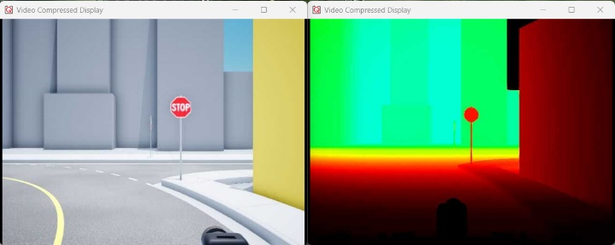Intel_Realsense.slx  
      This model should launch an RGB and Depth video display on your screen. An example output is shown here (RGB on left, Depth on right).

If your depth display looks monotonous, try reducing the **Maximum pixel value** parameter in the **Image Transform** block inside the **depthDisplay** subsystem.

* 1. CSI_Cameras.slx   
     This model should display one CSI image in a video display on your screen depending on the camera ID constant (0 to 3) in the model’s root level. A sample output is shown below (in order, 0 - right, 1 - rear, 2 - left and 3 - front camera).

|  |  |
| --- | --- |
| 0 | 1 |
| 2 | 3 |

* 1. RP_LIDAR_A2.slx  
     This model should display a polar plot of the LIDAR scans. A sample output is shown here. Note that the 0-degree mark corresponds to the front of the vehicle, and the data is scanned in a counterclockwise positive direction.

* 1. Basic_IO.slx  
     This model should let you command the throttle and steering motors and write high (**1**) or low (**0**) values to the 8 LEDs. In addition, you can also read the motor current, battery voltage and motor speed. You should see the wheels spin forwards for a positive throttle, and the front wheels steer towards the left for a positive steering (resulting in counterclockwise rotation).

# Python

## Hardware Tests

1. Check User Manual – Software Python for information on how to deploy python applications. Run each test one at a time on your system. Select virtual QCar2 in the terminal when prompt.
2. The expected behaviour is as follows:   
   1. hardware_tests_intelrealsense.py  
      This script should launch an RGB and Depth window on your screen. An example output is shown here (RGB on left, Depth on right).

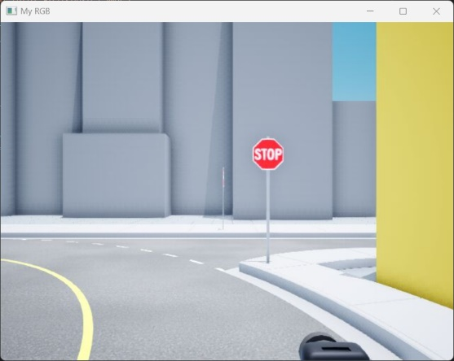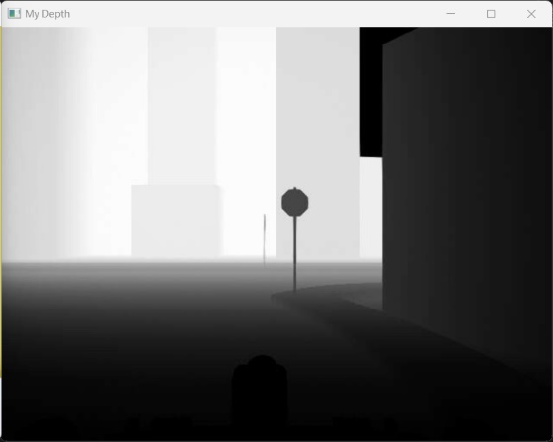

* 1. hardware_tests_csi_cameras.py   
     This script should display images from all CSI cameras in multiple windows on your screen. A sample output is shown below (in order, 0 - right, 1 - rear, 2 - left and 3 - front camera).

|  |  |
| --- | --- |
| 0 | 1 |
| 2 | 3 |

* 1. hardware_test_rp_lidar_a2.py

This application should display a polar plot of the LIDAR scans. A sample output is shown here.

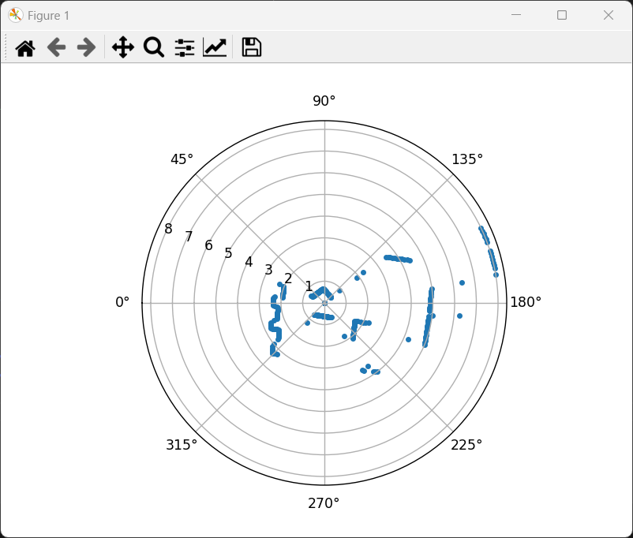

* 1. hardware_test_basic_io.py  
     This script should automatically drive a sinusoidal throttle and steering command to the wheels. As the steering changes left and right, the corresponding LED indicators should light up. As the wheels spin forward or backwards, the corresponding headlamps or rear lamps/reverse indicators should light up.